**Main Sources of Error**

* Moving Average Filter -> (there was no error, you just have to specify a large number of points for the filter since the interpolation interval is really small to ensure no data loss)
* Glitch Check (not really an error, but I don’t know how to make sure it worked)
* Cycle Detection -> works better, but not perfectly (solution: apply moving average and data spike remover regardless just to determine cycles)

**MTS ONLY DATASET TESTING:**

**Dataset: Priscilla’s 7 Cycles (ALL ISSUES RESOLVED)**

Without moving average filter or glitch checking:

* Works fine

With glitch checking, without moving average filter:

* Works fine

With moving average filter, without glitch checking:

* Detected incorrect amount of cycles
* Filtered and unfiltered measurements are the same on moving average plots
* Moving average doesn't seem to be applied in final plots

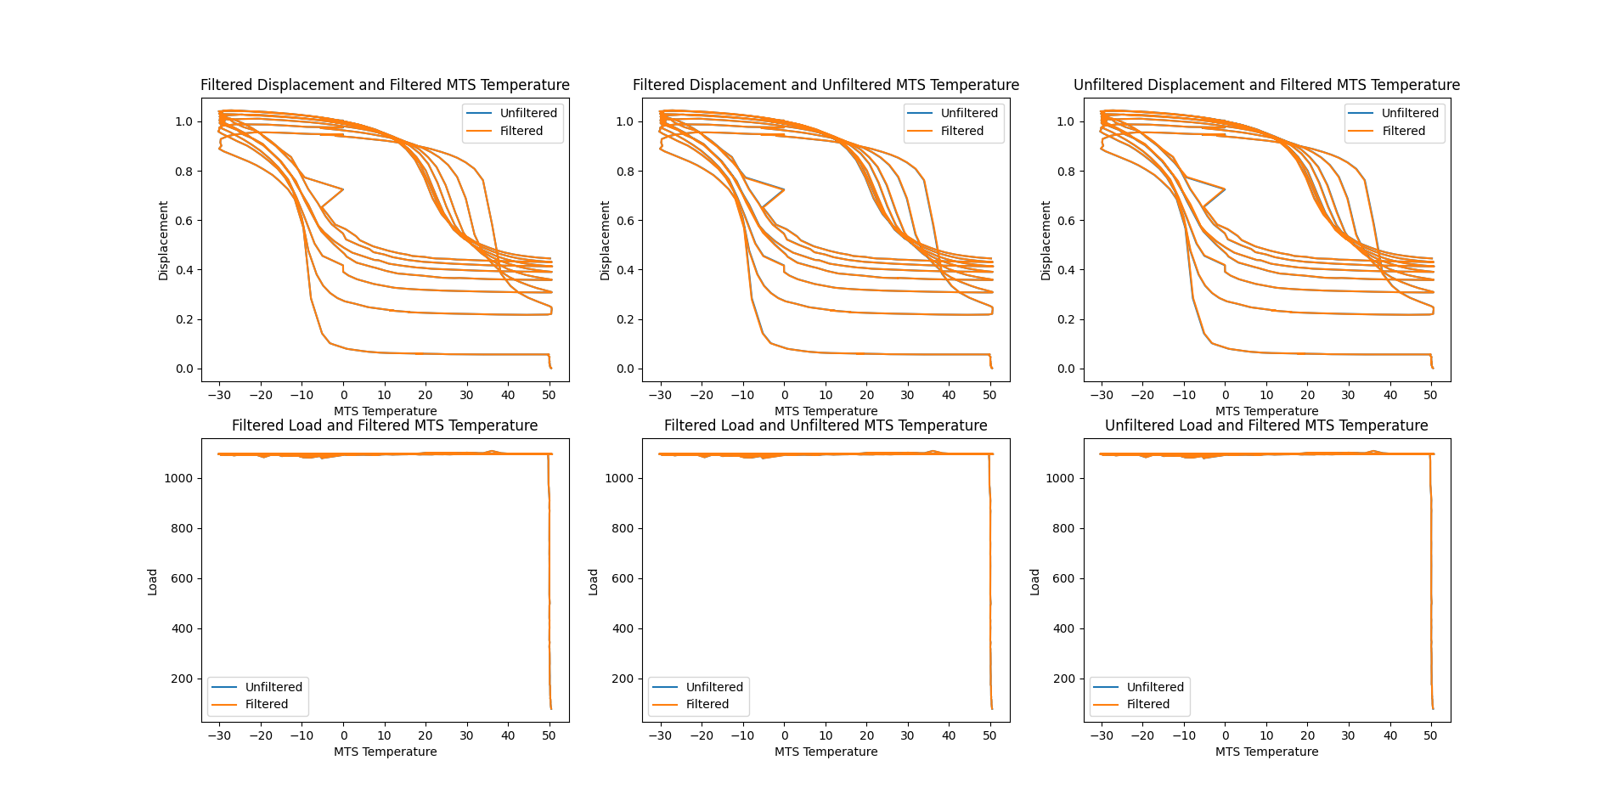

With moving average filter and glitch checking:

* Same issues as previous test

**Dataset: Priscilla’s Wire 3 NiHiTf 5 cycles (SOME ISSUES RESOLVED)**

Without moving average filter or glitch checking:

* Incorrect amount of cycles detected
* Looks like the plot is missing some data when compared to the plot in the drive for this dataset
* 3d plot looks wrong

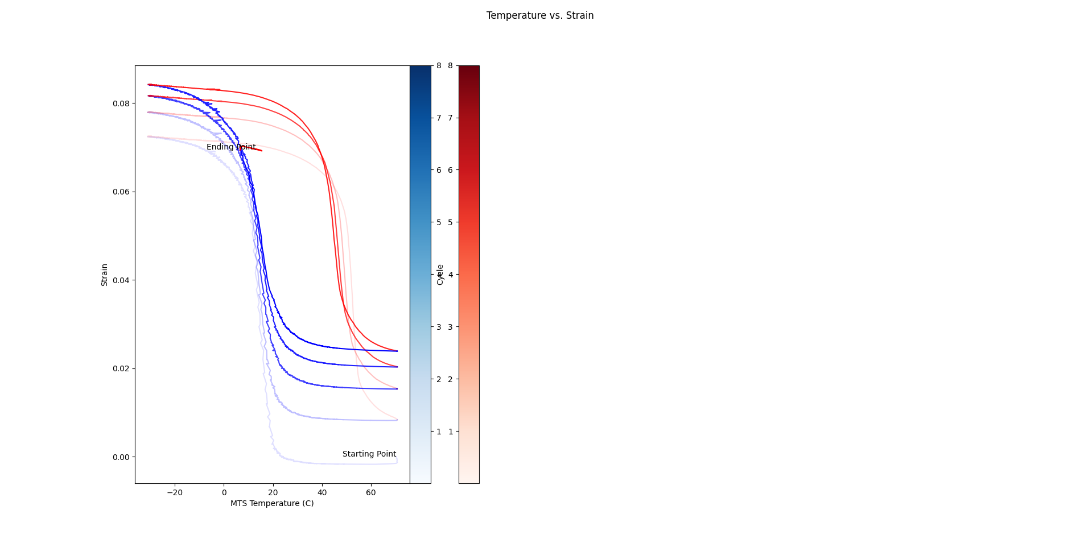

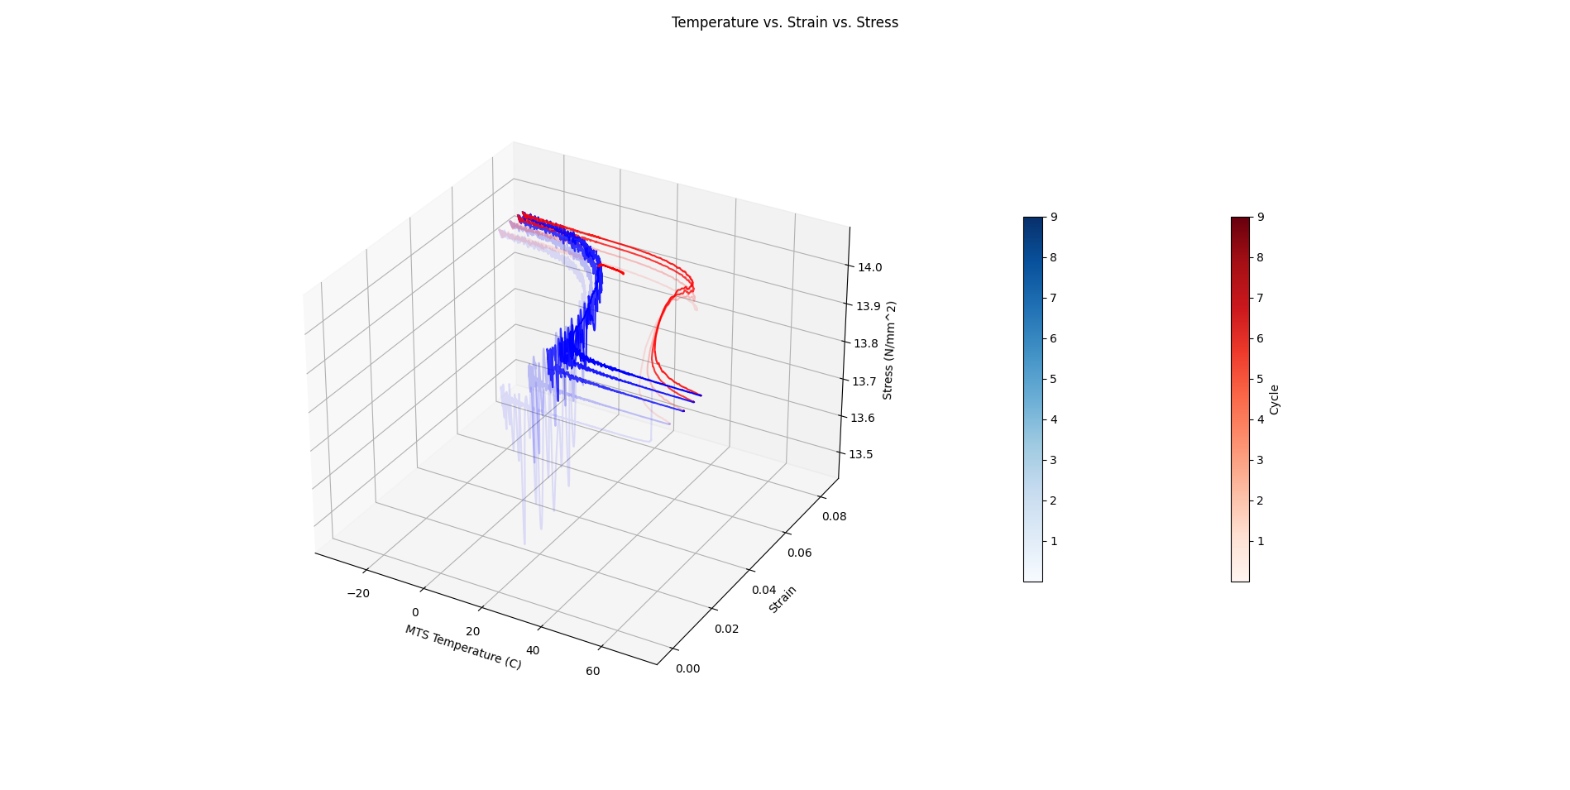

With glitch checking, without moving average filter

* Same issues as previous test

With moving average filter, without glitch checking

* Moving average doesn't seem to be applied in final plots
* Unfiltered and filtered measurements seem to be the same in moving average plots
* Cycle count is even more off
  + Without the filter, it detected 8 cycles and with the filter, it detected 9

With moving average filter and glitch checking

* Same issues as previous test

**Takeaway:** cycle detection tolerance needs to be adjusted, but the issue is the margin of adjustment is insanely large, which causes other datasets to not be analyzed correctly

* Originally the tolerance was set to 25, however in order to detect the correct number of cycles for this dataset, the tolerance had to be increased to 500, which causes cycle detection in other datasets to fail
* **NOTE: when a moving average filter was applied to this dataset with the tolerance set to 25 rather than 500, the correct number of cycles was detected. This seems to make sense as once the noise is removed from the data, the tolerance does not need to be high for cycle detection to work properly

**Dataset: Priscilla’s NiTiPd.txt (ALL ISSUES RESOLVED)**

Without moving average filter or glitch checking:

* Works fine

With glitch checking, without moving average filter

* Works fine

With moving average filter, without glitch checking

* Moving average filter does not seem to be applied in final plots
* Filtered and unfiltered measurements in moving average plots look the same

With moving average filter and glitch checking

* Same issues as previous test

**MTS WITH FLUKE DATASET TESTING**

**Dataset: Jacob’s 3 cycles test (ALL ISSUES RESOLVED)**

Without moving average filter or glitch checking

* Works fine

With glitch checking, without moving average filter

* Works fine

With moving average filter, without glitch checking

* Moving average filter does not seem to be applied in final plots
* Filtered and unfiltered measurements in moving average plots look the same

With moving average filter and glitch checking

* Same issues as previous test

**Dataset: Jacob’s LMSMA2 test (ALL ISSUES RESOLVED)**

Without moving average filter or glitch checking

* Works fine

With glitch checking, without moving average filter

* Does not work at all because the temperature readings on the mts are all 0 (should be an easy fix)

With moving average filter, without glitch checking

* Looks like it works fine

**FEATURE LIST:**

**Time Sync**

* Works for all datasets tested

**Glitch Checking**

* Works for all datasets tested

**Moving Average Filter**

* Works for all datasets tested

**Cycle Detection**

* Works for all datasets tested with the exception of Priscilla’s Wire3 5_cycles test (see above for details)

**Bandpass Filter**

* In progress